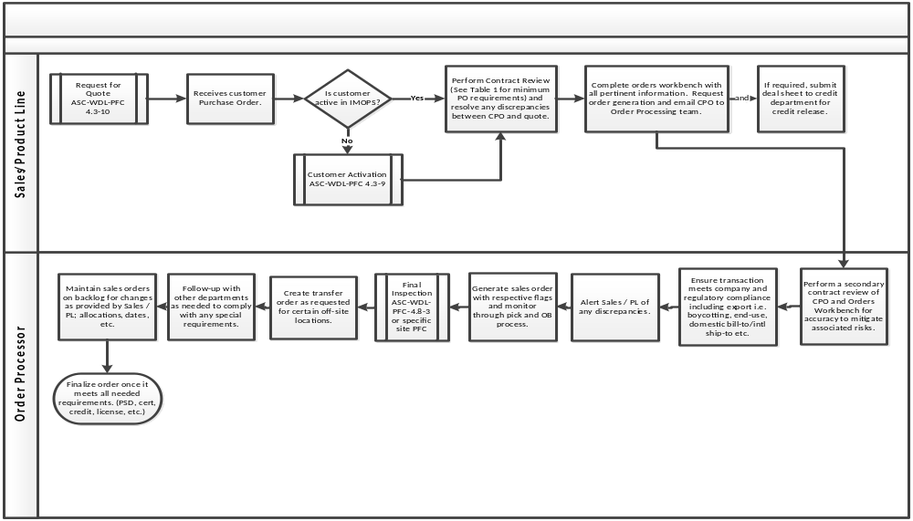

Table #1
ATC and AAM/D Customer Purchase Orders Required Information for Revenue Recognition
Commercial Sales (Non-Contractual) Required Info: | Changes that Require Written Customer Acceptance:
Purchase Order Number | Yes
Unit Price | Yes
Part Number Exception: certain assembly units | Only if PN supplied is not an alternate
Quantity | Only if quantity is being increased
Ship to Address/Delivery Address | Stating “default” will suffice when applicable
Customer Name
ATC and AAM/D ships on an ASAP basis unless instructed otherwise. Sales or Product Line personnel shall obtain authorization in writing if shipping 2 weeks or earlier than customer’s original date.
INFORMATION TO BE REVIEWED WHEN PROVIDED ON CUSTOMER PURCHASE ORDER
Freight Terms |  | Ship Via and Service Level
Bill To |  | FOB Destination Terms Require Written Waiver for Revenue Recognition
Part Condition
Payment Terms
Ship / Due Date (Delivery Dates) For revenue recognition purposes, Sales or Product Line personnel shall obtain authorization in writing if shipping 2 weeks or earlier than customer’s original due date.
ADDITIONAL INFORMATION TO BE REVIEWED IF APPLICABLE
AAR standards will be applied in cases where customer requirements are not specified
Customer mandatory and regulatory requirements * applicable to the products and services
Post Delivery Requirements if applicable
Applicable documents scanned to ERP and shall be retained
* example of but not limited to FAA/EASA/ITAR/IATA/DPAS regulations

